Topics: Descriptive Statistics and Probability

- Look at the data given below. Plot the data, find the outliers and find out
Name of company | Measure X
Allied Signal | 24.23%
Bankers Trust | 25.53%
General Mills | 25.41%
ITT Industries | 24.14%
J.P.Morgan & Co. | 29.62%
Lehman Brothers | 28.25%
Marriott | 25.81%
MCI | 24.39%
Merrill Lynch | 40.26%
Microsoft | 32.95%
Morgan Stanley | 91.36%
Sun Microsystems | 25.99%
Travelers | 39.42%
US Airways | 26.71%
Warner-Lambert | 35.00%

Answer:-
Mean | 33.27
Variance | 287.146612380952
Standard Deviation | 16.945400921222
Outliers | 91.36

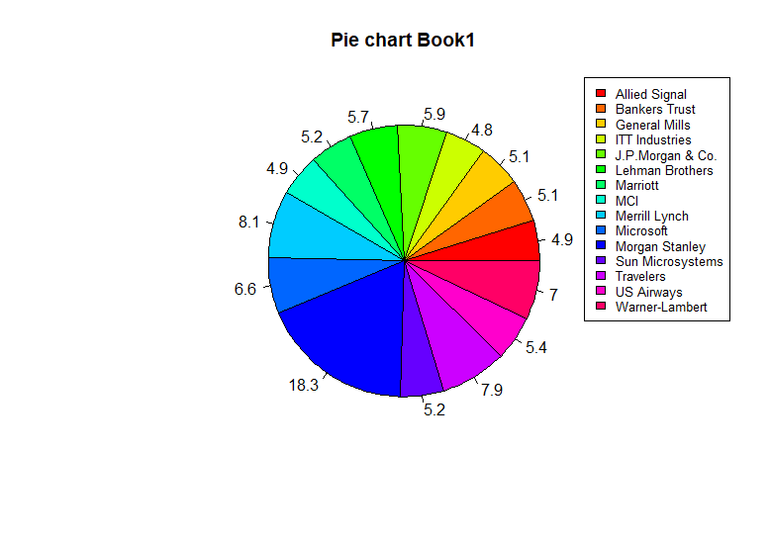
CODE:-
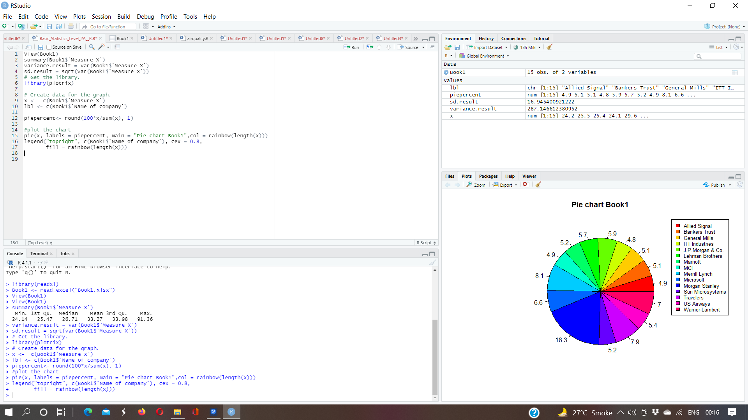

- Answer the following three questions based on the box-plot above.

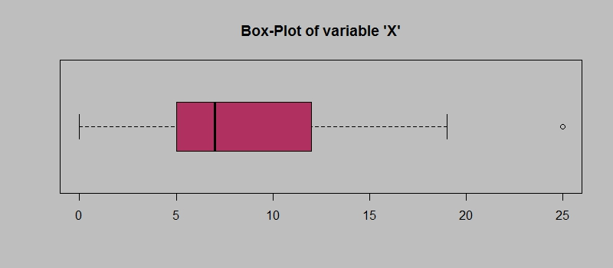

- What is inter-quartile range of this dataset? (please approximate the numbers) In one line, explain what this value implies.
- What can we say about the skewness of this dataset?
- If it was found that the data point with the value 25 is actually 2.5, how would the new box-plot be affected?
Answer:-
- upper IQR =1.5+(12-5) =8.5
Lower IQR = 1.5-(12-5) =6.5
- It is a positive skewness because the data is present on right side
- there will be no outlier

- Answer the following three questions based on the histogram above.

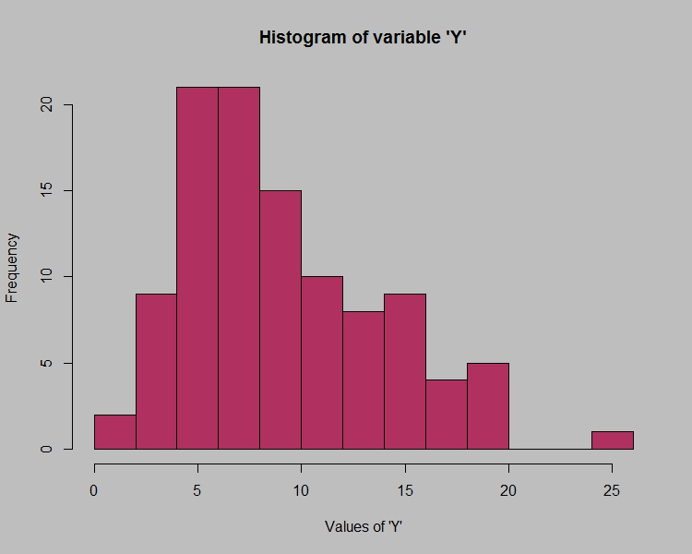

- Where would the mode of this dataset lie?
- Comment on the skewness of the dataset.
- Suppose that the above histogram and the box-plot in question 2 are plotted for the same dataset. Explain how these graphs complement each other in providing information about any dataset.
Answer:-
- The Mode of this dataset lie in between 4 to 8
- The skewness of the dataset is positive skewness beacuse its tail on the right side.
- Histogram is used to find out mode, skewness, kurtosis and boxplot is used to find out IQR and outliers.

- AT&T was running commercials in 1990 aimed at luring back customers who had switched to one of the other long-distance phone service providers. One such commercial shows a businessman trying to reach Phoenix and mistakenly getting Fiji, where a half-naked native on a beach responds incomprehensibly in Polynesian. When asked about this advertisement, AT&T admitted that the portrayed incident did not actually take place but added that this was an enactment of something that “could happen.” Suppose that one in 200 long-distance telephone calls is misdirected. What is the probability that at least one in five attempted telephone calls reaches the wrong number? (Assume independence of attempts.)
Answer:-
The total no. Of calls 200
One wrong no. Out of 200
Probability of wrong number = 1\200 = 0.005
Probability of not wrong number = 1-0.005
=0.995
Probability of atleast one out of five is a wrong number
= 1 – probability of atleast one out of five calls are not wrong numbers
= 1 – (1 – 0.005)^5
= 1 – 0.975
= 0.024
= 2.5%

- Returns on a certain business venture, to the nearest $1,000, are known to follow the following probability distribution
x | P(x)
-2,000 | 0.1
-1,000 | 0.1
0 | 0.2
1000 | 0.2
2000 | 0.3
3000 | 0.1

- What is the most likely monetary outcome of the business venture?
- Is the venture likely to be successful? Explain
- What is the long-term average earning of business ventures of this kind? Explain
- What is the good measure of the risk involved in a venture of this kind? Compute this measure
Answer:-
- The most likely monetary outcome of the business venture is 0.3
- yes the venture likely to be successful p(x=1000)+p(x=2000)+p(x=3000)=0.2+0.3+0.1=0.6
- The long-term average earning of business venture is
(0.1)(-2000)+(0.1)(-1000)+(0.2)(0)+(0.2)(1000)+(0.3)(2000)+(0.1)(3000)= 800
- The good measure of the risk involved in a venture of this kind is standard deviation.

